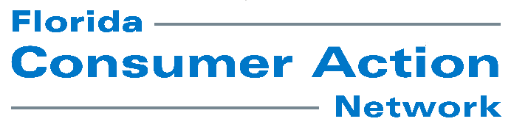

For Immediate Release: Monday, November 23, 2020

For Additional Information:
Susan McGrath, FCAN Executive Director, susan@fcan.org 727-278-9062
Grace Brombach, PIRG Consumer Watchdog Associate, 651-788-0005, grace@pirg.org

35th annual Trouble in Toyland report uncovers
mislabeled and dangerous toys
As holidays near, spotlight on nine toy hazards to avoid during gift-giving, sheltering-in-place

Tampa, FLA. – Florida Consumer Action Network (FCAN) and U.S. Rep. Kathy Castor, Florida District 14, today released the 2020 Trouble in Toyland report that has helped identify dangerous toys for 35 years. But according to FCAN Executive Director Susan McGrath, “2020 is unique because so many of us are at home because of COVID-19, children could be more susceptible to certain toy-related hazards.”

“This has been an incredibly difficult year, and parents and caregivers are overwhelmed. Parents often trust that manufacturers and online vendors have tested toys for sale and are guaranteeing their safety. Unfortunately, this isn’t always the case, so parents need to be on guard,” said McGrath. “That’s why we’re issuing this report.”

Because of the pandemic, many parents are working from home while trying to keep kids of multiple ages busy with safe activities they can perform without supervision. This can be a daunting task. That’s why Grace Brombach, US PIRG Consumer Watchdog, said “Busy parents may not know that many toys have hidden dangers or missing warning labels and playthings such as magnets, balloons and smaller toys can be deadly if they fall into younger children’s hands, according to the new Toy Report.”

Major findings:

- Choking Hazards: From small parts included in toy sets, to game pieces, many toys are not safe for children 2 years old or younger. This year’s report uncovered multiple examples of choking hazards that either lack a proper warning online or don’t have the mandatory warning label on the packaging.
- Loud Noises: Incredibly noisy toys played on repeat aren’t just annoying. According to the World Health Organization (WHO), sounds with decibel levels of more than 80 can cause potential hearing damage in children, and noises between 100 and 120 decibels can cause damage if they last more than one minute. Our researchers found a toy fire truck for sale on Amazon noisy enough to potentially damage a kid's hearing.
- High-Powered Magnets: Magnets of all types have posed risks to children for years. Some are part of toy building sets aimed at children as young as 3 years old, although some children that age don’t know not to eat or inhale them. And some magnets aren’t intended for kids; they’re more like fidget toys for adults, who can use “recreational” magnets to create shapes or figures. Sadly, these cases are found all too often in our emergency rooms.
- Recalled Toys: Researchers from U.S. PIRG Education Fund found three separate recalled toys for sale on eBay, and in two cases, found full pages selling the recalled products. Parents need to be especially careful buying from unknown sellers over the internet.
“The pandemic has led to more unsupervised play for children of all ages,” said McGrath. More play should be great for kind, and it can be IF parents are alert and take preventative steps. Prevention is the best medicine! To protect your children, do your homework and make sure dangerous products don’t get into your house in the first place.”
The report can be downloaded from FCAN’s web site at https://www.fcan.org

The Florida Consumer Action Network (FCAN) is a grassroots organization which empowers citizens to influence public policy by organizing and educating in areas where consumer voices are underrepresented. FCAN is an affiliate of the Public Interest Network and the Consumer Federation of America.

###

