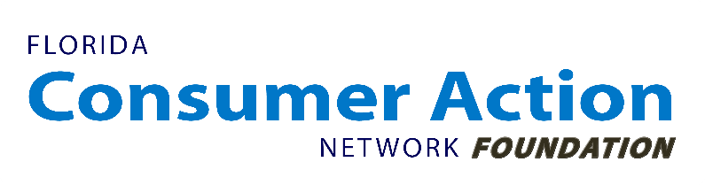

For Immediate Release:
March 6, 2019

For Additional Information:
Bill Newton, FCANF executive director, 727-685-0655 billn@fcan.org
Lance Kilpatrick, (202) 546-9707, lkilpatrick@pirg.org
Reuben Mathew, (315) 749-4501, rmathew@pirg.org

Prices of common medications can vary by hundreds of dollars New survey reveals large disparities, little logic in retail Rx pricing

[St. Petersburg, FLA]: While many Americans struggle to afford their prescription drugs, Florida Consumer Action Network Foundation today released a survey of retail prices of commonly prescribed medications found patients can save hundreds, even thousands of dollars in some cases by shopping around at pharmacies within their communities.

"Americans shouldn’t have to forgo life-saving medicines. But when they don't realize there are more affordable options at a different pharmacy, some have to do exactly that,” said Bill Newton, FCAN Foundation executive director. “Our medications don’t work any better when we pay more for them. We need a transparent prescription drug system that delivers value to patients at a reasonable price, instead of confusing and price-gouging them."

Retail prescription drug spending represents about 10 percent of the overall national health expenditures in America, while nearly 1 in 4 Americans struggle to afford their prescription drugs primarily because of inflated prices.

FCAN Foundation’s report, The Real Price of Medications: A Survey of Pharmaceutical Prices, released today, reveals a wide variation in the retail pricing of prescription drugs by pharmacies large and small, urban and rural.

The report, executive summary, press release, and FAQ may be found at https://www.fcanfoundation.org/prescription-drug-prices

The authors surveyed more than 250 pharmacies in 11 states for cash prices on 12 common drugs. Researchers found that consumers face a dizzying array of price differences:

- Patients could save from $102 - $5,400 a year between minimum and median prices of the selected medications by shopping around.
- Prescription drug price variation appeared disconnected from where the medicines were sold in urban and rural locations across many states; the median price for the surveyed brand and generic drugs varied an average of 892 percent from the cheapest available price.
- Switching from brand name drugs to generic alternatives can help save money. For example, switching from the brand acid reflux medication Nexium to its generic could save a patient an estimated $756 annually.
- Brand name drugs did not adjust to competition from generic drugs, even years after they entered the market. For instance, patients who switch from branded Lipitor to its generic could save an estimated $3,927 annually.
- Large chain pharmacies tend to have higher prices than their small chain or independent counterparts, despite having more leverage in the marketplace. Eight of the 12 drugs in the survey had higher median prices of 8.8 percent to 840 percent at large chains compared to small or independent pharmacies.

The authors point out that these high prices negatively impact the value patients get from medications, adding that paying more for their life-saving medicines doesn’t make you any healthier -- and the added expense can make treatments harder while triggering hard financial tradeoffs.

“The status quo can’t continue. Patients can’t afford it, for their health or their finances. We need our government to address the problem and make sure that Americans get the value they deserve from their health care,” finished Newton.

# # #

Florida Consumer Action Network Foundation, Inc. is a nonprofit, nonpartisan organization that advocates on issues including health care, insurance, finance, and transportation.

