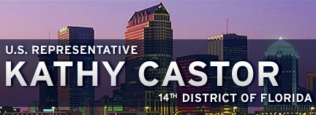
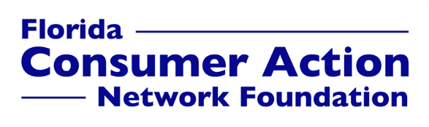

For Immediate Release: Tuesday, November 23, 2021

Contact Information:
Susan McGrath, FCAN Director, susan@fcan.org, 727-323-1785
Lisa Razler, BayCare Public Relations Manager, Lisa.Razler@BayCare.org, 813-924-2418
Marcia Mejia, District Director Kathy Castor, Marcia.Jejia@mail.house.gov, 813-871-2817

36th annual Trouble in Toyland report exposes risks of counterfeit and other dangerous toys

With the holidays around the corner, Rep. Kathy Castor, St. Joseph’s Children’s Hospital and Florida Consumer Action Network call attention to toy safety concerns

TAMPA, FL — Even though legitimate toymakers deserve kudos for making many of their products safer over the years, too often, Americans end up buying dangerous toys for children for the holidays. Florida Consumer Action Network Foundation’s 36th annual Trouble in Toyland report shows that many of those toys are counterfeit or recalled products, but still make their way into consumers’ shopping carts.

“The handful of greedy Grinches who are putting children at risk to put more money in their pockets have hearts two sizes too small,” said Susan McGrath, FCAN Foundation’s Executive Director. “We need a concerted effort by federal regulators and toy vendors to keep dangerous toys off the market. And, while it’s not fair that gift-buyers need to keep an eye out for counterfeit or recalled items, all of us need to check to protect our kids.”

“While the latest trend in toys changes each year, child safety doesn’t go out of style,” said Dr. Juan Carlos Abanses, medical director of the Steinbrenner Children’s Emergency Room at St. Joseph’s Children’s Hospital. “Some common toy-related injuries we see in older children include lacerations, fractures and abrasions, and the biggest risk for young children is ingestion of small toy parts, batteries and magnets.”

It’s not always easy to determine whether a gift is safe or not, especially online, when you can’t inspect the item and it may be mislabeled, or missing a warning, such as a recall notice. So far in 2021, the Consumer Product Safety Commission (CPSC) has recalled 13 toys. In addition, researchers found two additional recalled products — a hoverboard and a children’s watch accessory — that many would consider toys. The recalled toys posed risks including high levels of lead, potential ingestion by a child and small parts from easily broken toys.

Here are the main categories in this year’s report:

- Knockoff toys on the market: Knockoffs used to be found on a street vendor’s table. Nowadays, knockoffs and counterfeit toys can be bought online, often from overseas, where manufacturers don’t always follow U.S. regulations. Our researchers identified knockoff toys on the marketplace and the safety concerns they can pose to children. See our tips guide to learn how to avoid counterfeit toys.
- Second-hand toys: People often sell their used goods online without checking to see whether they have been recalled. That can be a big problem when it comes to toys. We found previously recalled toys for sale on eBay.
- Choking hazards: Our researchers found discrepancies between website descriptions and warning labels for toys with small parts. Toys advertised for “age 2” had small parts that are unsafe for children under the age of 3.
- Noisy toys: Noisy toys are not only a nuisance in the home, but also at risk to children’s hearing. Toy researchers identified five noisy toys and tested the noise levels replicating how a child would use the toy.
- Smart toys: We identified privacy issues concerning smart toys looking at three categories: cameras and recording devices built into toys, unsecure mobile apps used to control toys and personalized online accounts that store data specifically about the toy and the toy user.
“Fake products sold by unreputable sellers have the potential to be unsafe, because they are unlikely to comply with strict product safety laws,” said Ed Desmond, executive vice president of The Toy Association of America, a not-for-profit trade organization. He said reputable companies test their products for compliance with more than 100 different safety standards and tests required by law. “These counterfeit toys might have small parts that can break off, may not be age-graded appropriately, or may pose other risks to children.”
McGrath of FCAN added, “It’s easy, when you’re thinking of how fun a toy can be, to overlook how dangerous it can be. We all want kids to have fun, but we also want kids to be safe. When it comes to holiday shopping, ignorance is not bliss.”

Florida Consumer Action Network Foundation is a non-profit, non-partisan group that stands for an America where everyone gets their fair share, does their fair share, and pays their fair share; and where everyone plays by the same rules. FCAN Foundation is part of the Public Interest Network and is affiliated with the Consumer Federation of America.

####

