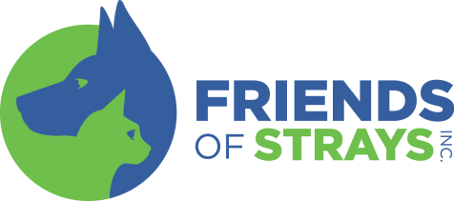
ADOPTION APPLICATION
Name:___________________________________________________ Phone #: ___________________________Date: ________
Street Address: ___________________________________________________________________________________________
City:_____________________________________________________________State:___________________Zip:_____________
Email address: ____________________________________________________________________________________________
Do you: Own Rent Live with family
Landlord ______________________ Phone #______________________
Employer__________________________ Phone #______________________
Who are you adopting this pet for? (circle one) Yourself Relative Friend Pet
Have you previously adopted a cat or dog from Friends of Strays? Yes No
Have you adopted a cat/dog from another shelter or rescue group? Yes No
Do you have other animals at home? Yes No
If yes, please list all animals below (name, breed, age):
____________________________________________________________________________________________________________________________________________________________________________________
Is the entire family that lives in your home aware of this adoption? Yes No
Please list the ages of any children: _______________________________________________________
Who is the secondary contact if we cannot reach you and your cat/dog is in possession of Animal Control or our shelter?
Name:_________________________________________________ Phone #:__________________________
In the event of an emergency, who can care for your pet indefinitely?
Name: ________________________________________________ Phone #: __________________________
How did you hear about us?
PetFinder FOS Web Site Adopted from FOS in the past
Event __________ Staff Member Volunteer
Word of Mouth Friend Other:_______________________
Would you be willing to join the Hills Science Diet email list to further help the animals in our care?
Yes No

For Cats Only:
Have you ever had your cat or kitten declawed? Yes No
How do you feel about declawing?_______________________________________________________

Agreement:
I certify the above information is true. I understand giving false information on this application is grounds for denying my application. This application remains the property of Friends of Strays Animal Shelter, Inc.
Applicant Signature:_________________________________________________________________________________________ Driver’s License Number:__________________________________________________________________________________

